**Integration test**

**Visitor part**

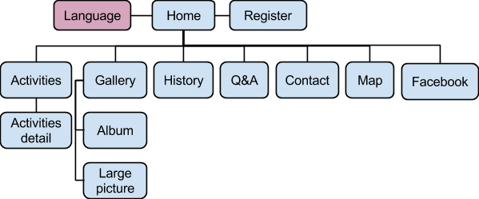

**Home page - Register page**

|  |  |  |  |
| --- | --- | --- | --- |
| **Test case ID** | **Test case Object** | **Test case Description** | **Expected**  **Result** |
| 1 | Check the interface link between the Home page and Register page | Select register button | To be directed to the Register page. |

**Home page - Language module**

|  |  |  |  |
| --- | --- | --- | --- |
| **Test case ID** | **Test case Object** | **Test case Description** | **Expected**  **Result** |
| 1 | Check the interface link between the Home page and Language module | Select language button (EN/TH) | Display selected language on the website |

**Home page - Activities page - Activities detail page**

|  |  |  |  |
| --- | --- | --- | --- |
| **Test case ID** | **Test case Object** | **Test case Description** | **Expected**  **Result** |
| 1 | Check the interface link between the Home page and Activities page | Select activities link on menu bar. | To be directed to the Activities page. |
| 2 | Check the interface link between the Activities page and Activities detail page | From Activities page select an activity topic link | To be directed to Activities detail page of selected activity. |

**Home page - Gallery page - Album page – Picture**

|  |  |  |  |
| --- | --- | --- | --- |
| **Test case ID** | **Test case Object** | **Test case Description** | **Expected**  **Result** |
| 1 | Check the interface link between the Home page and Gallery page | Select gallery link on the menu bar | To be directed to the Gallery page. |
| 2 | Check the interface link between the Gallery page and Album page | Select album link in the gallery page | To be directed to the Album page. |
| 3 | Check the interface link between the Album page and Large picture page | Select Large picture link in the album page | To be directed to the Album Large picture page. |

**Home page - History page**

|  |  |  |  |
| --- | --- | --- | --- |
| **Test case ID** | **Test case Object** | **Test case Description** | **Expected**  **Result** |
| 1 | Check the interface link between the Home page and History page | Select history link on the menu bar | To be directed to the History page. |

**Home page - Q&A page**

|  |  |  |  |
| --- | --- | --- | --- |
| **Test case ID** | **Test case Object** | **Test case Description** | **Expected**  **Result** |
| 1 | Check the interface link between the Home page and Q&A page | Select q&a link on the menu bar | To be directed to the Q&A page. |

**Home page - Contact page**

|  |  |  |  |
| --- | --- | --- | --- |
| **Test case ID** | **Test case Object** | **Test case Description** | **Expected**  **Result** |
| 1 | Check the interface link between the Home page and Contact page | Select contact link on the menu bar | To be directed to the Contact page. |

**Home page - Map page**

|  |  |  |  |
| --- | --- | --- | --- |
| **Test case ID** | **Test case Object** | **Test case Description** | **Expected**  **Result** |
| 1 | Check the interface link between the Home page and Map page | Select map link on the menu bar | To be directed to the Map page. |

**Home page - Facebook fan page**

|  |  |  |  |
| --- | --- | --- | --- |
| **Test case ID** | **Test case Object** | **Test case Description** | **Expected**  **Result** |
| 1 | Check the interface link between the Home page and Facebook fan page. | Select Facebook icon on the menu bar | To be directed to the Wat Phra Singh Facebook fan page. |

**Member part**

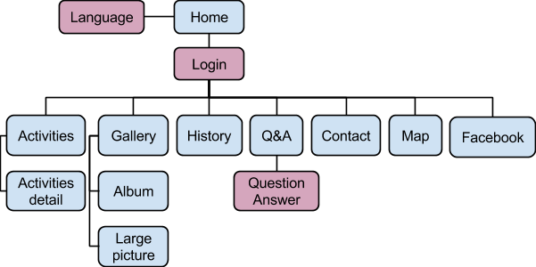

**Home page - Language module**

|  |  |  |  |
| --- | --- | --- | --- |
| **Test case ID** | **Test case Object** | **Test case Description** | **Expected**  **Result** |
| 1 | Check the interface link between the Home page and Language module | Select language button (EN/TH) | Display selected language on the website |

**Home page - Login module**

|  |  |  |  |
| --- | --- | --- | --- |
| **Test case ID** | **Test case Object** | **Test case Description** | **Expected**  **Result** |
| 1 | Check the interface link between the Home page and Login module | Fill in login form and select login button | Redirect to Home page and display user name |

**Home page - Login module - Activities page - Activities detail page**

|  |  |  |  |
| --- | --- | --- | --- |
| **Test case ID** | **Test case Object** | **Test case Description** | **Expected**  **Result** |
| 1 | Check the interface link between the Home page and Login module | Fill in login form and select login button | Redirect to Home page and display user name |
| 2 | Check the interface link between the Login module and Activities page | Select activities link on menu bar. | To be directed to the Activities page. |
| 3 | Check the interface link between the Activities page and Activities detail page | From Activities page select an activity topic link | To be directed to Activities detail page of selected activity. |

**Home page - Login module - Gallery page - Album page – Picture**

|  |  |  |  |
| --- | --- | --- | --- |
| **Test case ID** | **Test case Object** | **Test case Description** | **Expected**  **Result** |
| 1 | Check the interface link between the Home page and Login module | Fill in login form and select login button | Redirect to Home page and display user name |
| 2 | Check the interface link between the Login module and Gallery page | Select gallery link on the menu bar | To be directed to the Gallery page. |
| 3 | Check the interface link between the Gallery page and Album page | Select album link in the gallery page | To be directed to the Album page. |
| 4 | Check the interface link between the Album page and Large picture page | Select Large picture link in the album page | To be directed to the Album Large picture page. |

**Home page - Login module - History page**

|  |  |  |  |
| --- | --- | --- | --- |
| **Test case ID** | **Test case Object** | **Test case Description** | **Expected**  **Result** |
| 1 | Check the interface link between the Home page and Login module | Fill in login form and select login button | Redirect to Home page and display user name |
| 2 | Check the interface link between the Login module and History page | Select history link on the menu bar | To be directed to the History page. |

**Home page - Login module - Q&A page - Question Answer module**

|  |  |  |  |
| --- | --- | --- | --- |
| **Test case ID** | **Test case Object** | **Test case Description** | **Expected**  **Result** |
| 1 | Check the interface link between the Home page and Login module | Fill in login form and select login button | Redirect to Home page and display user name |
| 2 | Check the interface link between the Login module and Q&A page | Select q&a link on the menu bar | To be directed to the Q&A page |
| 3 | Check the interface link between the Question and Question Answer module | Fill in question form and select submit button | Update question to database |

**Home page - Login module - Contact page**

|  |  |  |  |
| --- | --- | --- | --- |
| **Test case ID** | **Test case Object** | **Test case Description** | **Expected**  **Result** |
| 1 | Check the interface link between the Home page and Login module | Fill in login form and select login button | Redirect to Home page and display user name |
| 2 | Check the interface link between the Login module and Contact page | Select contact link on the menu bar | To be directed to the Contact page. |

**Home page - Map page**

|  |  |  |  |
| --- | --- | --- | --- |
| **Test case ID** | **Test case Object** | **Test case Description** | **Expected**  **Result** |
| 1 | Check the interface link between the Home page and Login module | Fill in login form and select login button | Redirect to Home page and display user name |
| 2 | Check the interface link between the Login module and Map page | Select map link on the menu bar | To be directed to the Map page. |

**Home page - Facebook fan page**

|  |  |  |  |
| --- | --- | --- | --- |
| **Test case ID** | **Test case Object** | **Test case Description** | **Expected**  **Result** |
| 1 | Check the interface link between the Home page and Login module | Fill in login form and select login button | Redirect to Home page and display user name |
| 2 | Check the interface link between the Login and Facebook fan page. | Select Facebook icon on the menu bar | To be directed to the Wat Phra Singh Facebook fan page. |

**Admin part**

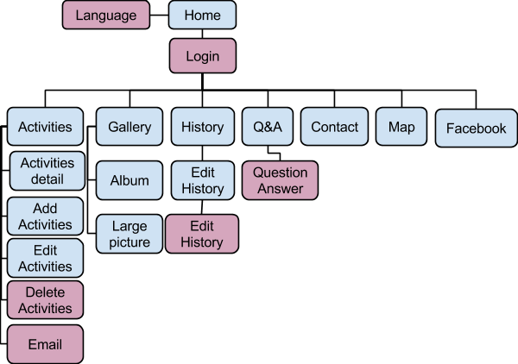

**Home page - Language module**

|  |  |  |  |
| --- | --- | --- | --- |
| **Test case ID** | **Test case Object** | **Test case Description** | **Expected**  **Result** |
| 1 | Check the interface link between the Home page and Language module | Select language button (EN/TH) | Display selected language on the website |

**Home page - Login module**

|  |  |  |  |
| --- | --- | --- | --- |
| **Test case ID** | **Test case Object** | **Test case Description** | **Expected**  **Result** |
| 1 | Check the interface link between the Home page and Login module | Fill in login form and select login button | Redirect to Home page and display user name |

**Home page - Login module - Activities page - Add activities page.**

|  |  |  |  |
| --- | --- | --- | --- |
| **Test case ID** | **Test case Object** | **Test case Description** | **Expected**  **Result** |
| 1 | Check the interface link between the Home page and Login module | Fill in login form and select login button | Redirect to Home page and display user name |
| 2 | Check the interface link between the Login module and Activities page | Select activities link on menu bar | To be directed to the Activities page |
| 3 | Check the interface link between the Activities page and Add activities page | From Activities page select add button | Add new activity to the database and redirect to the Activities page |

**Home page - Login module - Activities page - Activities detail page - Edit activities page**

|  |  |  |  |
| --- | --- | --- | --- |
| **Test case ID** | **Test case Object** | **Test case Description** | **Expected**  **Result** |
| 1 | Check the interface link between the Home page and Login module | Fill in login form and select login button | Redirect to Home page and display user name |
| 2 | Check the interface link between the Login module and Activities page | Select activities link on menu bar | To be directed to the Activities page. |
| 3 | Check the interface link between the Activities page and Activities detail page | From Activities page select an activity topic link | To be directed to Activities detail page of selected activity. |
| 4 | Check the interface link between the Activities detail page and Edit activities page | From Activities detail page select edit button | Update activity detail to the database and redirect to the Activities page |

**Home page - Login module - Activities page - Activities detail page - Delete activities page**

|  |  |  |  |
| --- | --- | --- | --- |
| **Test case ID** | **Test case Object** | **Test case Description** | **Expected**  **Result** |
| 1 | Check the interface link between the Home page and Login module | Fill in login form and select login button | Redirect to Home page and display user name |
| 2 | Check the interface link between the Login module and Activities page | Select activities link on menu bar. | To be directed to the Activities page. |
| 3 | Check the interface link between the Activities page and Activities detail page | From Activities page select an activity topic link | To be directed to Activities detail page of selected activity. |
| 4 | Check the interface link between the Activities detail page and Delete activities module | From Activities detail page select delete button | Delete activity from the database and redirect to the Activities page |

**Home page - Login module - Gallery page - Album page – Picture**

|  |  |  |  |
| --- | --- | --- | --- |
| **Test case ID** | **Test case Object** | **Test case Description** | **Expected**  **Result** |
| 1 | Check the interface link between the Home page and Login module | Fill in login form and select login button | Redirect to Home page and display user name |
| 2 | Check the interface link between the Login module and Gallery page | Select gallery link on the menu bar | To be directed to the Gallery page. |
| 3 | Check the interface link between the Gallery page and Album page | Select album link in the gallery page | To be directed to the Album page. |
| 4 | Check the interface link between the Album page and Large picture page | Select Large picture link in the album page | To be directed to the Album Large picture page. |

**Home page - Login module - History page - Edit history page - Update history module**

|  |  |  |  |
| --- | --- | --- | --- |
| **Test case ID** | **Test case Object** | **Test case Description** | **Expected**  **Result** |
| 1 | Check the interface link between the Home page and Login module | Fill in login form and select login button | Redirect to Home page and display user name |
| 2 | Check the interface link between the Login module and History page | Select history link on the menu bar | To be directed to the History page. |
| 3 | Check the interface link between the History page and Edit history page | From the History page select edit button | To be directed to the Edit history page |
| 4 | Check the interface link between the Edit history page and Update history module | From the Edit history page select edit button | Update history in database and redirect to the History page |

**Home page - Login module - Q&A page - Question Answer module**

|  |  |  |  |
| --- | --- | --- | --- |
| **Test case ID** | **Test case Object** | **Test case Description** | **Expected**  **Result** |
| 1 | Check the interface link between the Home page and Login module | Fill in login form and select login button | Redirect to Home page and display user name |
| 2 | Check the interface link between the Login module and Q&A page | Select q&a link on the menu bar | To be directed to the Q&A page |
| 3 | Check the interface link between the Question and Question Answer module | Fill in answer form and select submit button | Update answer to database |
| 4 | Check the interface link between the Question and Question Answer module | From Q&A page select delete button | Delete the question from database |

**Home page - Login module - Contact page**

|  |  |  |  |
| --- | --- | --- | --- |
| **Test case ID** | **Test case Object** | **Test case Description** | **Expected**  **Result** |
| 1 | Check the interface link between the Home page and Login module | Fill in login form and select login button | Redirect to Home page and display user name |
| 2 | Check the interface link between the Login module and Contact page | Select contact link on the menu bar | To be directed to the Contact page. |

**Home page - Map page**

|  |  |  |  |
| --- | --- | --- | --- |
| **Test case ID** | **Test case Object** | **Test case Description** | **Expected**  **Result** |
| 1 | Check the interface link between the Home page and Login module | Fill in login form and select login button | Redirect to Home page and display user name |
| 2 | Check the interface link between the Login module and Map page | Select map link on the menu bar | To be directed to the Map page. |

**Home page - Facebook fan page**

|  |  |  |  |
| --- | --- | --- | --- |
| **Test case ID** | **Test case Object** | **Test case Description** | **Expected**  **Result** |
| 1 | Check the interface link between the Home page and Login module | Fill in login form and select login button | Redirect to Home page and display user name |
| 2 | Check the interface link between the Login and Facebook fan page. | Select Facebook icon on the menu bar | To be directed to the Wat Phra Singh Facebook fan page. |